



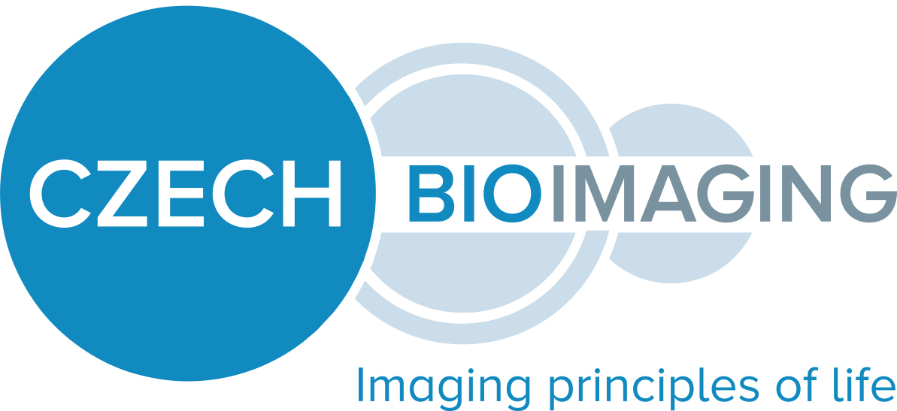

**Research Scientist for Electron microscopy laboratory**

Faculty of Natural Sciences, Charles University has an open position for research-technical staff scientist in electron microscopy for Imaging Methods Core Facility at BIOCEV center (http://imcf.natur.cuni.cz)

**Job description:**

* Routine and advanced tasks in the field of electron microscopy for life-sciences applications
* Close interaction and communication with facility users and colleagues at the workplace
* Sample preparation, ultrastructural analysis, data processing, evaluation and presentation
* Preparation and optimization of tools and experimental methods
* Work with conventional and advanced laboratory equipment and laboratory IT system
* Independent management of microscopy analysis projects and project documentation
* Co-operation on facility maintenance and operations, including material re-stocking, reagents preparation, instrument calibration and testing etc.
* Assistance with other operations of the facility (user training, organization of practical courses, presentation of facility projects on conferences and workshops)

**Requirements:**

* University degree in biology, chemistry, bio-physics or related fields
* Knowledge of microscopy methods (Practical experience will be an advantage)
* Practical experience with work at laboratory and with laboratory equipment operations
* Diligence, patience, excellent manual skills and consistency at work
* Thorough management of project and laboratory documentation
* Independence and systematic multitasking in project management
* Pro-active approach to learning new methods and following literature and trends in the field
* Good organization and communication skills
* Practical knowledge of English (verbal and written)

**We offer:**

* Access to state-of-the-art microscopy technologies at well-resourced center
* Interesting and non-routine work contributing to excellent research
* Contribution to methods development and research project management
* Introduction and training in advanced imaging methods
* Possibility of curriculum development

**Workplace**: Imaging Methods Core Facility, BIOCEV, Průmyslová 595, Vestec, Prague-West

252 50, Czech Republic

**Contract**: Initially 1 year with 3 months of probation period and perspective of (repetitive) 3-year extension. Full-time staff scientist (VP1 grade, classification of Charles University)

**Expected date**: As soon as possible. The job offer stays open until position is filled.  
  
In case of interest, please submit your structured CV and motivation letter by email to: [kadlecokr](https://urldefense.proofpoint.com/v2/url?u=http-3A__goog-5F170834129&d=DwMFaQ&c=q6k2DsTcEGCcCb_WtVSz6hhIl8hvYssy7sH8ZwfbbKU&r=QSKBYtfn77MyZmdHK7i_s877_VuSbkc0483nB3k2QOM&m=qv0KQfsZyvdKs_AFArFZTXSaWbvH3s2Z00rdBKUN8aI&s=iTjgc1vIWtUfBwrvXvqwA3CmuIhaGU49j_OClC0vnmI&e=)[@natur.cuni.cz](http://natur.cuni.cz/)